**CreateNode-RED Service**

**Aim**: To create a web application create a Node-RED service.

Steps followed:

|  |  |
| --- | --- |
| **TEAM ID** | PNT2022TMID02457 |
| **Project Name** | A safety gadget for child safety monitoring and notification**.** |

# ● Navigated to the App creation page

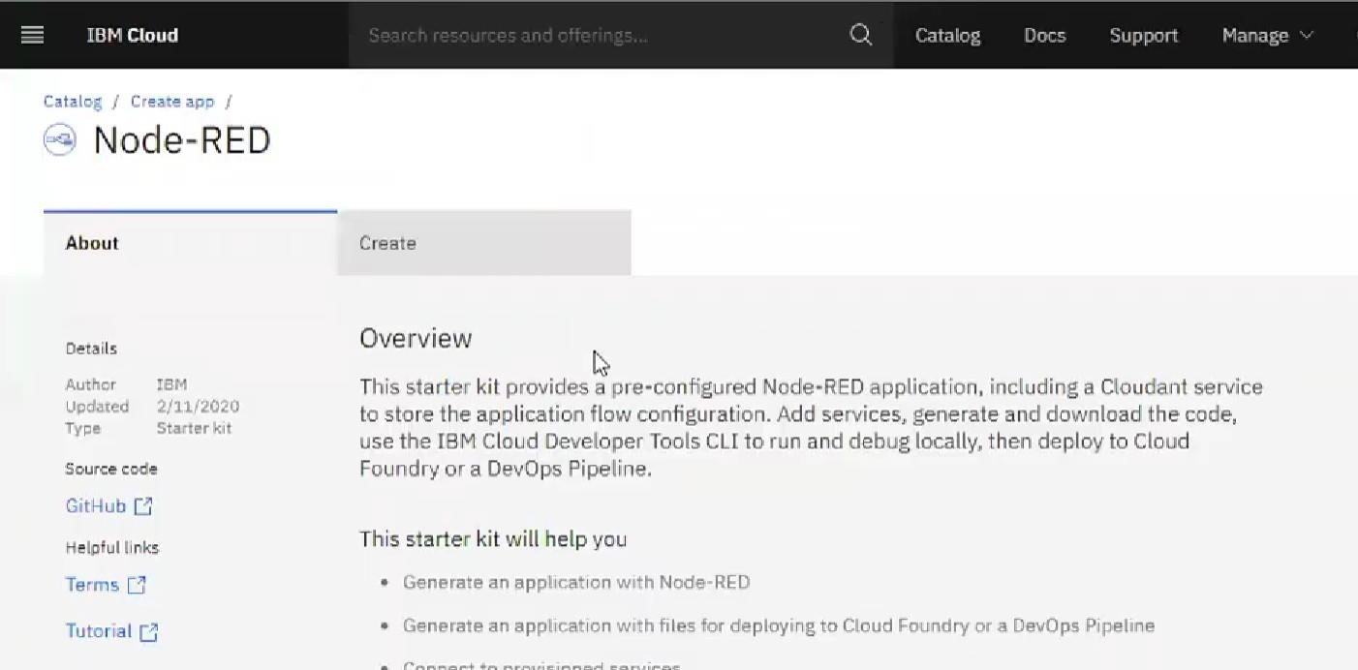

# ● Entered project details and clicked on create

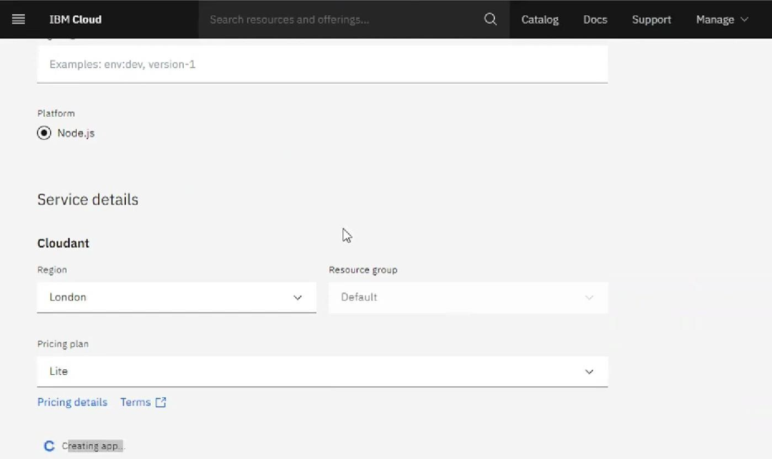

# Clicking on the “Deploy your App” Button

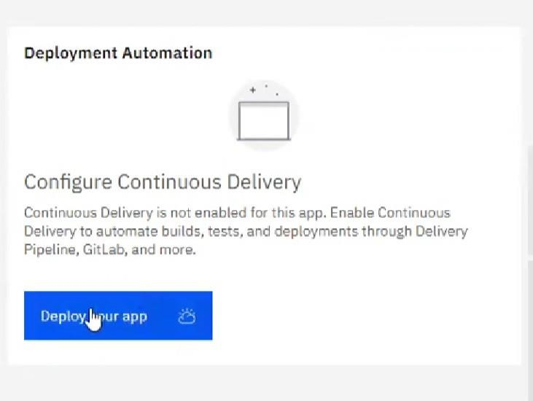

## ● Setting up the environment and deploying the app

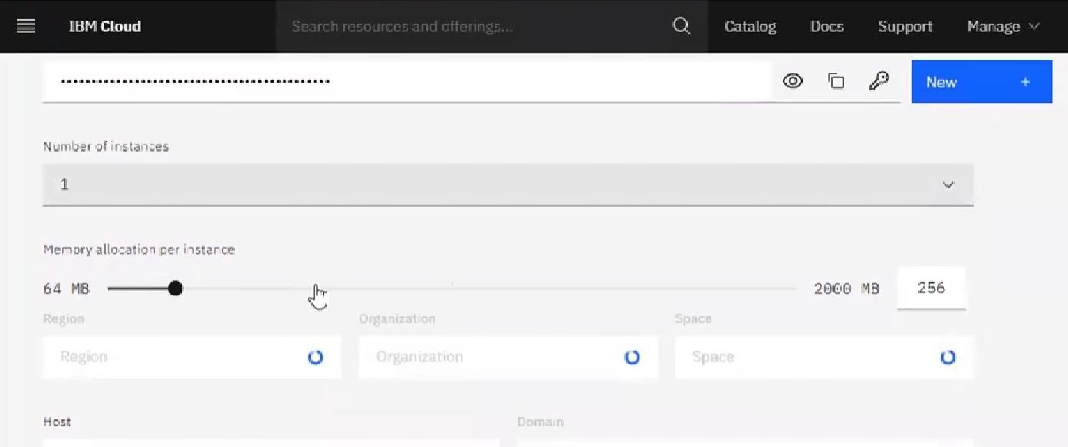

# Successfully deployed the app

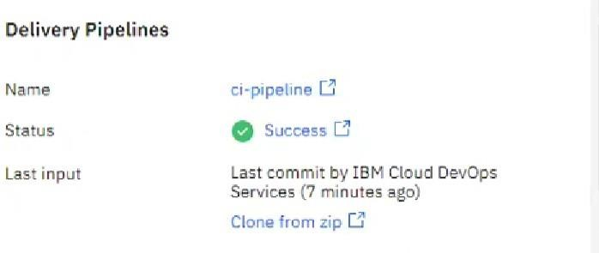

## ● Welcomed by the instance editor

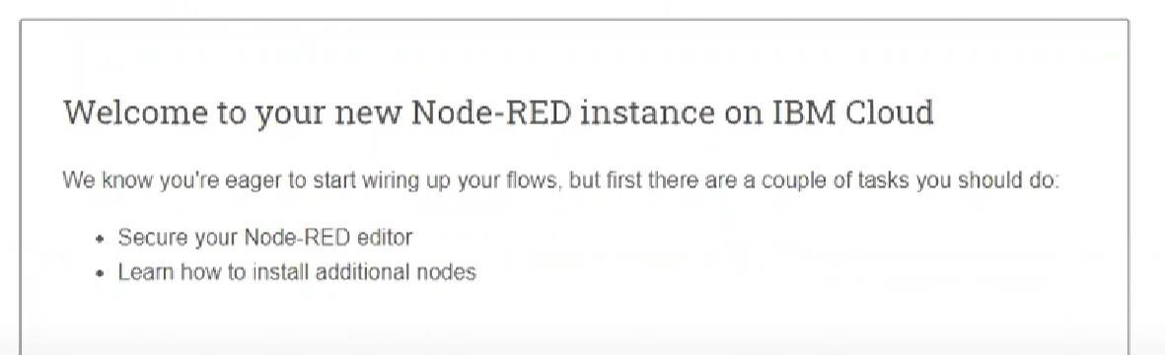

## ● Setting up credentials

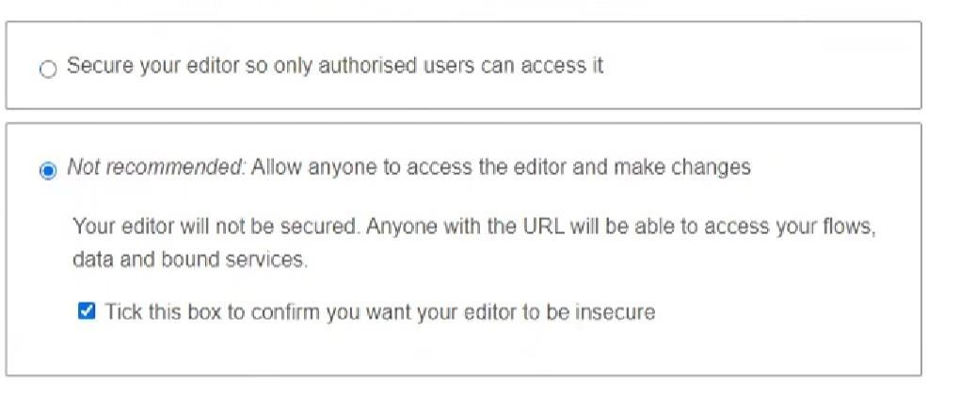

# Dragged and dropped components into the editor

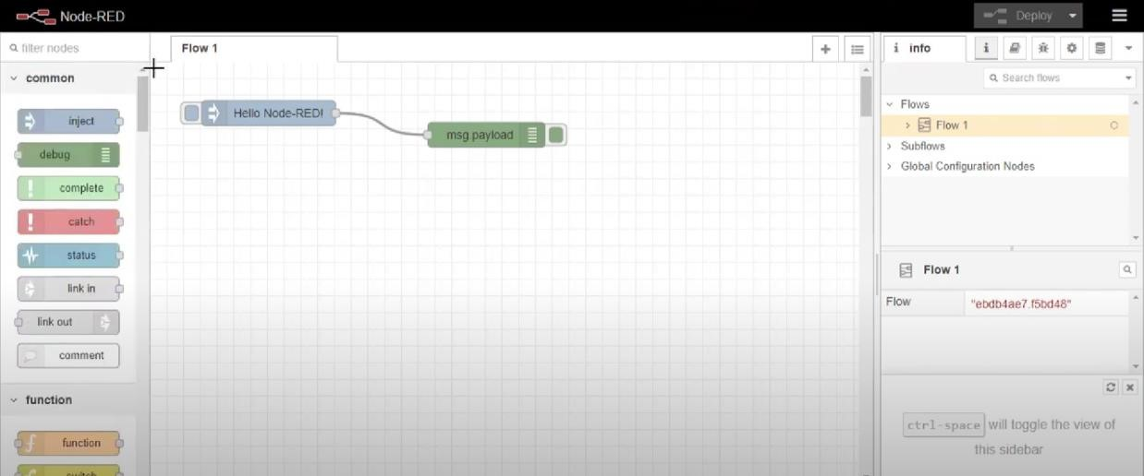

## ● Editing some values of the properties

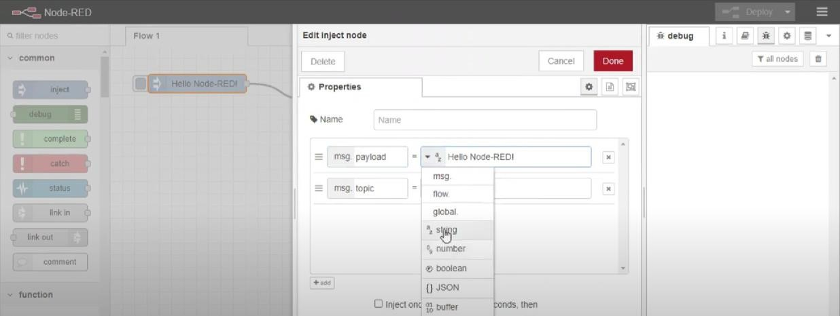

## ● Successfully deployed the app

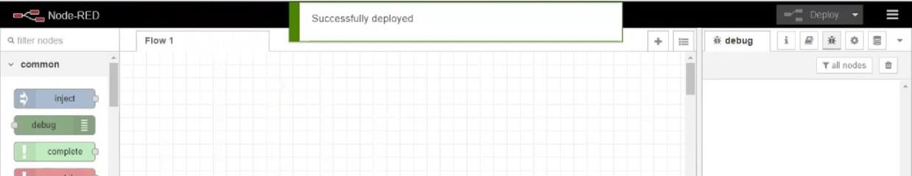

## **Result:** Successfully created a NodeRED service on IBM Cloud